CLASS ACTIVITY
UNIT V

Q1. Communication of Rare Surgical Risk

Aim
To evaluate two different ways of communicating a rare surgical complication risk to patients and determine which framing is more understandable for a layperson.

Problem Statement
A hospital communicates a 2% risk of a rare surgical complication in two ways:
- Version A: “There is a 2% chance of complication.”
- Version B: “Out of 100 patients like you, 2 will experience a complication.”
The objective is to determine which representation is easier for a general patient to understand.
Dataset
Version Risk Percentage Patients Considered Expected Complications
- – Percentage 2% 100 2
- – Natural Frequency 2% 100 2

Code
import matplotlib.pyplot as plt

versions = ["Version A\n2% chance", "Version B\n2 out of 100"] values = [2, 2]

plt.figure(figsize=(7, 5)) bars = plt.bar(versions, values)

plt.ylabel("Expected complications per 100 patients")
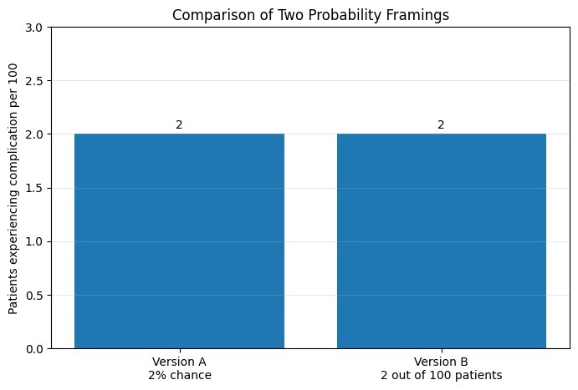
plt.title("Comparison of Risk Communication Formats") plt.ylim(0, 3)

for bar, value in zip(bars, values):
plt.text(bar.get_x() + bar.get_width()/2, value + 0.05, str(value), ha="center")

plt.show()

Result
Both versions communicate the same numerical probability: 2%. However, Version B is generally easier for a layperson to understand because it uses a natural-frequency format.
The statement “2 out of 100 patients” gives the patient a concrete reference group. In contrast, “2% chance” requires the patient to mentally convert a percentage into a frequency.

Interpretation
A well-known pitfall in probability communication is difficulty understanding percentages and probabilities, particularly when people are unfamiliar with statistical concepts. Natural frequencies can make small risks more concrete and easier to compare.

Conclusion
For a general layperson, “2 out of 100 patients” is likely to be understood more accurately than “2% chance.” Natural frequencies reduce the mental effort required to interpret a small probability. Therefore, Version B should be the default for patient-facing communication, while Version A can be used in technical or standardized medical contexts.

Q2. Forecast Uncertainty for Tomorrow's Rainfall

Aim
To compare a static confidence-interval band and an animated Hypothetical Outcome Plot (HOP) for communicating rainfall forecast uncertainty to a general public audience on a mobile application.

Problem Statement
A weather agency must choose between:
- Method A: Static confidence-interval band.
- Method B: Animated Hypothetical Outcome Plot showing simulated rainfall outcomes.
The methods are evaluated based on comprehension speed, risk of misinterpretation, and technical feasibility.

Dataset
The following simulated rainfall forecast data are used:
Hour | Forecast Rainfall (mm) | Lower Bound (mm) | Upper Bound (mm)
6 | 1.5 | 0.5 | 3.0
9 | 2.0 | 0.8 | 4.0
12 | 4.0 | 1.5 | 7.0
15 | 5.0 | 2.0 | 9.0
18 | 3.5 | 1.0 | 7.0
21 | 2.0 | 0.5 | 4.5
Code import numpy as np import matplotlib.pyplot as plt
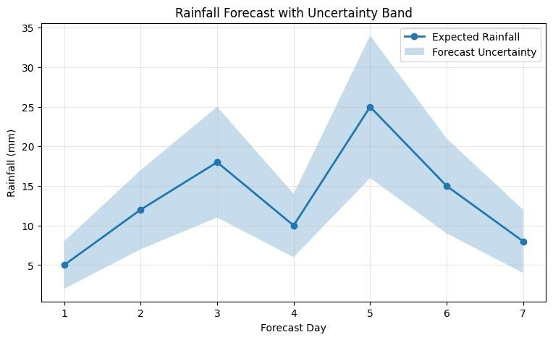
hours = np.array([6, 9, 12, 15, 18, 21]) forecast = np.array([1.5, 2.0, 4.0, 5.0, 3.5, 2.0]) lower = np.array([0.5, 0.8, 1.5, 2.0, 1.0, 0.5]) upper = np.array([3.0, 4.0, 7.0, 9.0, 7.0, 4.5])

plt.figure(figsize=(8, 5))

plt.plot(hours, forecast, marker="o", label="Forecast") plt.fill_between(hours, lower, upper, alpha=0.3, label="Uncertainty interval")

plt.xlabel("Time of Day") plt.ylabel("Rainfall (mm)") plt.title("Tomorrow's Rainfall Forecast Uncertainty")
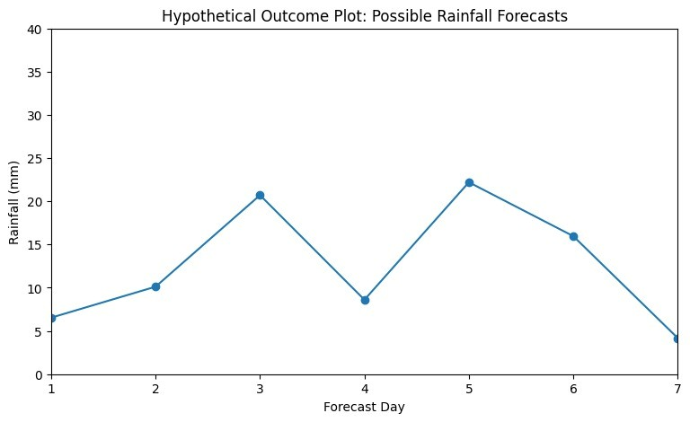
plt.legend() plt.grid(True, alpha=0.3)

plt.show()

Result
The static uncertainty band presents the forecast and its uncertainty in a single view. Users can quickly identify the expected rainfall and the range of possible outcomes.
An animated HOP can communicate uncertainty intuitively by repeatedly showing simulated possible rainfall outcomes. However, users must watch the animation to appreciate the Interpretation
For a general public mobile application, speed and simplicity are important. A static uncertainty band allows users to understand the forecast immediately without waiting for an animation.

Q3. Startup Revenue Growth and Bar Chart Design

Aim
To evaluate a startup revenue chart with respect to proportional ink, baseline selection, and axis scale, and determine whether correcting the chart strengthens the credibility of the growth story.

Problem Statement
A startup's revenue increases from ₹2 lakhs to ₹2 crores over three years. The original bar chart uses a linear axis with a non-zero baseline, causing the final bar to appear disproportionately large.

Dataset
Year | Revenue (₹ Lakhs) | Revenue (₹ Crores)
Year 1 | 2 | 0.02
Year 2 | 10 | 0.10
Year 3 | 200 | 2.00

Code
import matplotlib.pyplot as plt
v
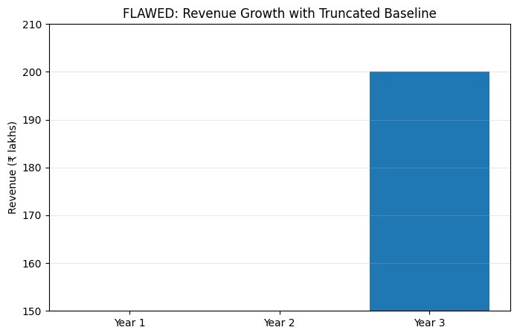
years = ["Year 1", "Year 2", "Year 3"] revenue = [2, 10, 200]

# Original chart with misleading baseline plt.figure(figsize=(7, 5)) plt.bar(years, revenue, bottom=1)

plt.ylabel("Revenue (₹ Lakhs)") plt.title("Original Revenue Chart with Non-Zero Baseline") plt.show()

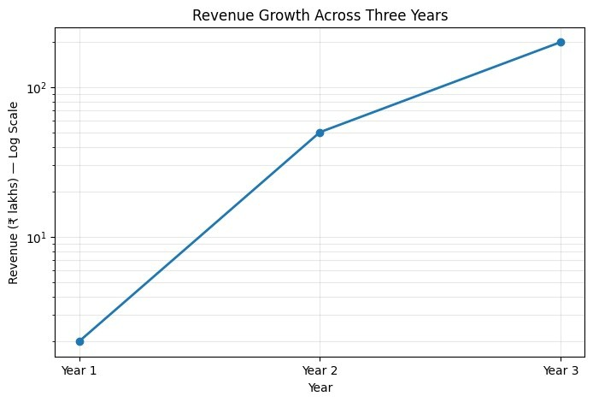
# Corrected chart plt.figure(figsize=(7, 5)) plt.bar(years, revenue)

plt.ylabel("Revenue (₹ Lakhs)")
plt.title("Corrected Revenue Chart with Zero Baseline") plt.show()

Result
The original chart exaggerates the visual difference between revenue values because the baseline does not start at zero.
A corrected bar chart beginning at zero represents the magnitude of each bar proportionally.

Interpretation
Bar charts rely heavily on the length of the bars to represent numerical magnitude. Therefore, a truncated baseline can exaggerate differences and violate the principle of proportional ink, where the visual amount used to represent data should correspond appropriately to the actual numerical values.
The corrected chart may initially appear less dramatic because the visual exaggeration has
.

Conclusion
The corrected zero-baseline chart strengthens the startup's story rather than weakening it. Although it removes visual exaggeration, it demonstrates that the growth is genuinely

Q4. COVID Dashboard Color Scale

Aim
To evaluate the use of rainbow/jet and red-green color scales in a public health dashboard based on perceptual accuracy, accessibility, and public trust.
District | Infection Rate per 10,000 | Risk Category
A | 15 | Low
B | 35 | Moderate
C | 60 | High
D | 85 | Very High
E | 110 | Critical

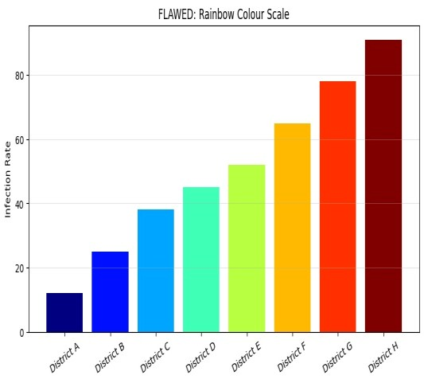
Problem Statement
A city COVID dashboard uses:
- A rainbow/jet color scale for infection rates.
- Red-green colors to represent safe and high-risk areas.
Both designs are evaluated for possible communication problems.
Dataset

Code
import matplotlib.pyplot as plt import numpy as np

districts = ["A", "B", "C", "D", "E"] infection_rate = [15, 35, 60, 85, 110]

# Rainbow/jet color scale
plt.figure(figsize=(8, 5)) plt.bar(districts, infection_rate,
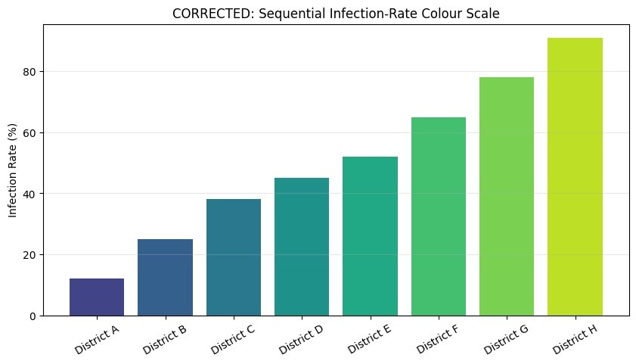
color=plt.cm.jet(np.linspace(0, 1, len(districts))))

plt.xlabel("District") plt.ylabel("Infections per 10,000")
plt.title("COVID Infection Rate – Rainbow Scale") plt.show()

# Alternative sequential scale plt.figure(figsize=(8, 5)) plt.bar(districts, infection_rate, color=plt.cm.viridis( np.linspace(0, 1, len(districts))))

plt.xlabel("District") plt.ylabel("Infections per 10,000") plt.title("COVID Infection Rate – Accessible Sequential Scale") plt.show()

Result
The rainbow/jet scale introduces several unnecessary color transitions. These transitions can make numerical differences appear larger or smaller than they actually are.
The red-green scheme has a major accessibility problem because people with certain forms of color-vision deficiency may have difficulty distinguishing red from green.
Ranking of Harm

1. Red-Green – More severe harm
Red-green is particularly problematic because it can completely prevent some users from distinguishing the two intended categories. During a health emergency, this could result in an incorrect understanding of risk.
.

Conclusion
Both color schemes should be replaced. Red-green has the greater accessibility risk, while rainbow/jet has significant perceptual problems. A colorblind-friendly sequential scale combined with labels would provide a more accurate and trustworthy COVID dashboard.

Q5. Visualization of 50,000 GPS Pings

Aim
To compare a plain scatter plot, 2D density contour map, and neighborhood-level bubble map for visualizing the spatial concentration of 50,000 ride-hailing GPS demand points.

Problem Statement
A ride-hailing company needs to visualize where demand is concentrated across a city. Three visualization techniques are considered:
- A: Plain scatter plot.
- B: 2D density contour map.
- C: Direct-area bubble map aggregated by neighborhood.

Dataset
A simulated dataset of 50,000 GPS pings is generated using several demand centers.
Area | Approximate GPS Pings | Demand Level
Downtown | 12,000 | Very High
Airport | 9,000 | High
Business District | 8,000 | High
Residential Area 1 | 6,000 | Moderate
Residential Area 2 | 5,000 | Moderate
Other Areas | 10,000 | Low/Moderate
Total | 50,000 | —
Code import numpy as np import matplotlib.pyplot as plt
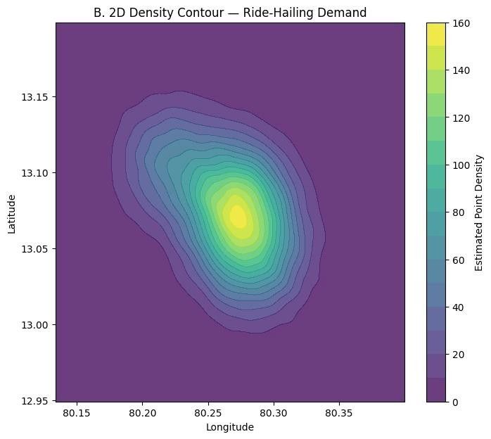
np.random.seed(42)

n = 50000

# Simulated city GPS locations centers = [
(20, 20),
(50, 70),
(70, 30),
(40, 45),
(80, 80)
]

weights = [0.25, 0.20, 0.18, 0.17, 0.20]

x = [] y = []

for (cx, cy), w in zip(centers, weights):

count = int(n * w)

x.extend(np.random.normal(cx, 5, count))
y.extend(np.random.normal(cy, 5, count))

x = np.array(x) y = np.array(y) # A. Plain scatter plot plt.figure(figsize=(7, 6)) plt.scatter(x, y, s=2, alpha=0.3) plt.xlabel("Longitude") plt.ylabel("Latitude") plt.title("A. Plain Scatter Plot – 50,000 GPS Pings") plt.show()

# B. 2D density contour plt.figure(figsize=(7, 6)) plt.hist2d(x, y, bins=50) plt.colorbar(label="Number of GPS Pings") plt.xlabel("Longitude") plt.ylabel("Latitude") plt.title("B. 2D Density Map") plt.show()

# C. Bubble-style aggregation bins = 10 hist, xedges, yedges = np.histogram2d(x, y, bins=bins)

xc = (xedges[:-1] + xedges[1:]) / 2 yc = (yedges[:-1] + yedges[1:]) / 2

X, Y = np.meshgrid(xc, yc)

plt.figure(figsize=(7, 6)) plt.scatter(X.flatten(), Y.flatten(), s=hist.T.flatten() * 0.5, alpha=0.6)

plt.xlabel("Longitude") plt.ylabel("Latitude") plt.title("C. Aggregated Bubble Map") plt.show()
Result

A. Plain Scatter Plot
The scatter plot displays individual GPS observations. It preserves the raw data and can reveal individual locations.
However, with 50,000 points, substantial overplotting occurs. Areas with many observations become visually crowded, making it difficult to determine exact density.

B. 2D Density Contour/Heat Map
The density visualization aggregates observations into spatial regions and clearly identifies high-demand and low-demand areas.
It reduces overplotting and is effective for identifying demand hotspots.

C. Direct-Area Bubble Map
The bubble map aggregates demand and represents the magnitude of observations through bubble size.
It is relatively easy for managers to interpret and can work well when the analysis is performed at neighborhood level.

